V2 change log
11/01/2023
- Adjusted the location return information is presented to create space for the addition of email delegate.
- Adjusted the spacing of the return data to be clearer for error handling.
- Corrected some spelling grammar errors in return data
- Added email delegate button
- Rearranged to a square layout
- Adjusted frame size
- Added label demarking optional email delegate
- Added label for delegate enumber
- Added capture field for delegate enumber
- Added the v6 removal using recycled known good code not tested

UI change
v2  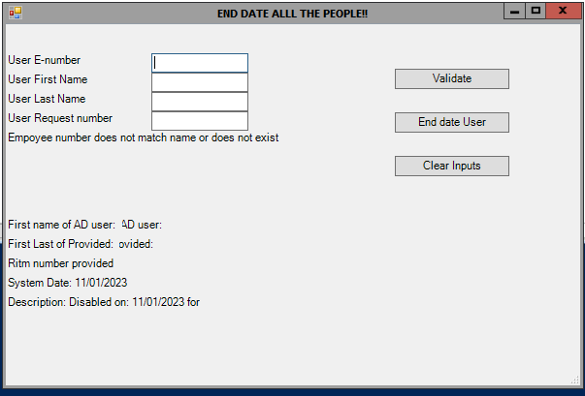 | V3  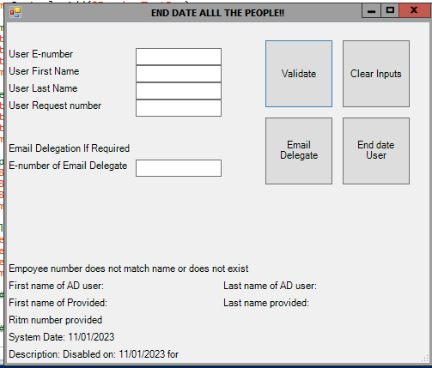

12/1/2023

- Added epics into the security group removal
- Added connect exchange,
  - This currently does not work in sgja298
  - look at pivot options:
    - migrate the app off 298 (ideal)
    - add exchange connect functionality to 298 (may get push back)
    - pause current project pending clarification on this

16//01/23
Roll back:
I have completed a separate application that when run external from the domain controller will complete the email functionality.
For now:
- keep altered UI changes.
- Add the code from the other application.
- Block out the code.

